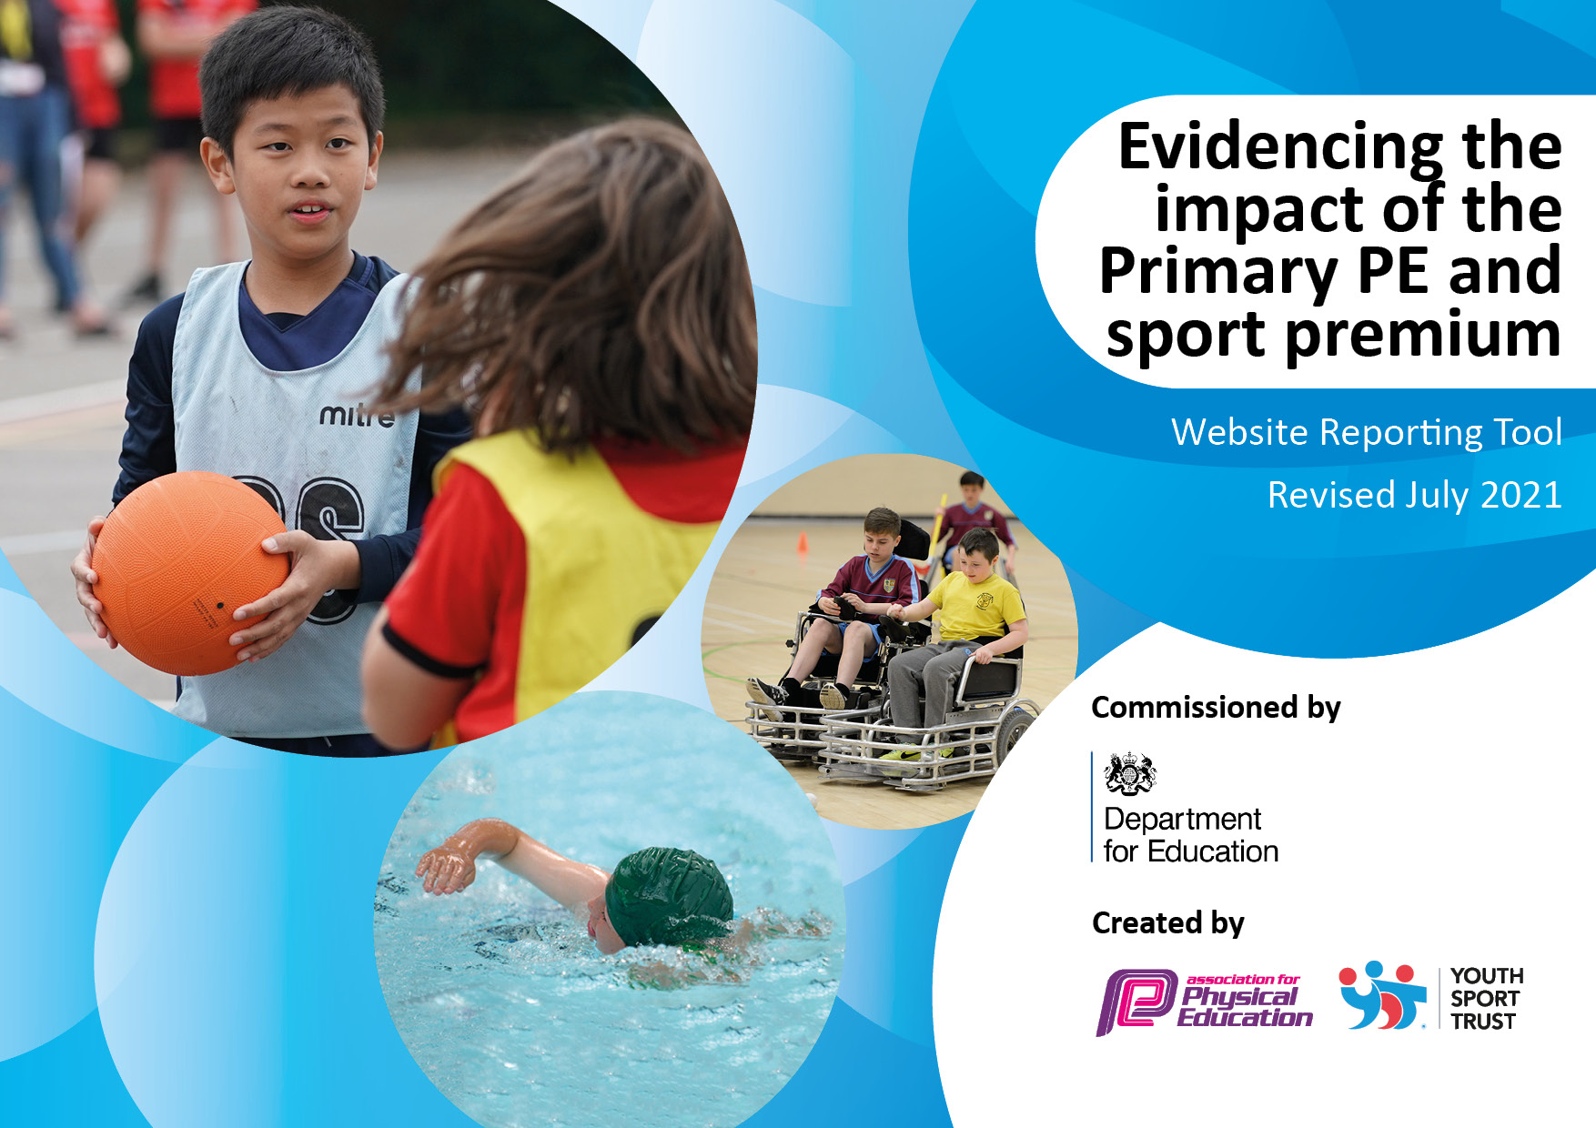

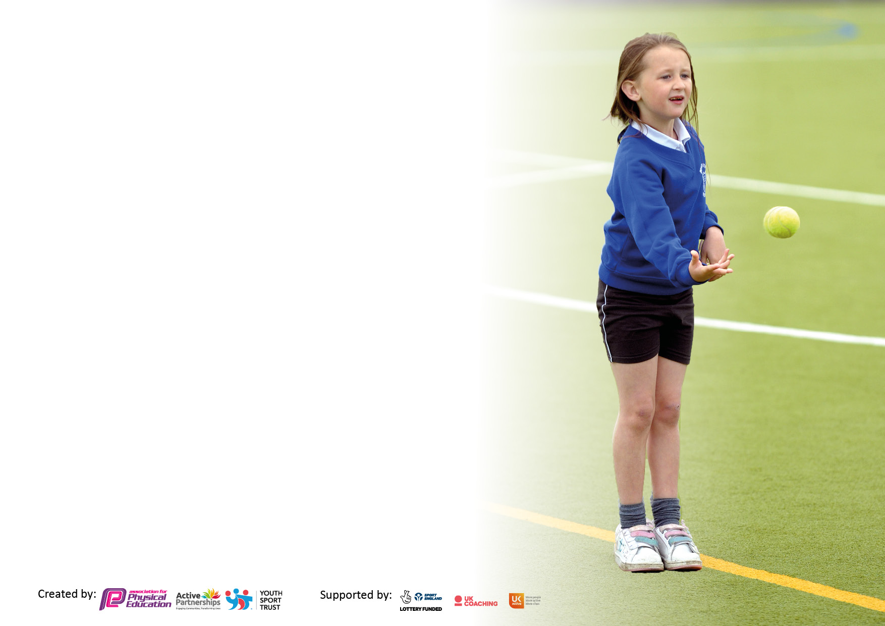

It is important that your grant is used effectively and based on school need. The Education Inspection Framework makes clear there will be a focus on **‘whether leaders and those responsible for governors all understand their respective roles and perform these in a way that enhances the effectiveness of the school’**.

Under the Quality of Education Ofsted inspectors consider:

**Intent** - Curriculum design, coverage and appropriateness

**Implementation** - Curriculum delivery, Teaching (pedagogy) and Assessment

**Impact** - Attainment and progress

To assist schools with common transferable language this template has been developed to utilise the same three headings which should make your plans easily transferable between working documents.

Schools must use the funding to make **additional and sustainable** improvements to the quality of Physical Education, School Sport and Physical Activity (PESSPA) they offer. This means that you should use the Primary PE and sport premium to:

* Develop or add to the PESSPA activities that your school already offer
* Build capacity and capability within the school to ensure that improvements made now will benefit pupils joining the school in future years
* The Primary PE and sport premium should not be used to fund capital spend projects; the school’s budget should fund these.

Pleasevisitgov.ukfortherevisedDfEguidanceincludingthe5keyindicatorsacrosswhichschoolsshoulddemonstrate animprovement.Thisdocumentwillhelpyoutoreviewyourprovisionandtoreportyourspend.DfEencouragesschools to use this template as an effective way of meeting the reporting requirements of the Primary PE and sport premium.

We recommend you start by reflecting on the impact of current provision and reviewing the previous spend.

Schools are required to publish details of how they spend this funding, including any under-spend from 2021/2022, as well as on the impact it has on pupils’ PE and sport participation and attainment. **All funding must be spent by 31st July 2023.**

We recommend regularly updating the table and publishing it on your website throughout the year. This evidences your ongoing self-evaluation of how you are using the funding to secure maximum, sustainable impact. Final copy must be posted on your website by the end of the academic year and no later than the 31st July 2023. To see an example of how to complete the table please click HERE.

Created by: Supported by:

**Details with regard to funding**

Please complete the table below.

Langton CP School Sport s Premium 22-23

|  |  |
| --- | --- |
| Total amount allocated for 2022/23 | £ 16930 |

**Swimming Data**

Please report on your Swimming Data below.

|  |  |
| --- | --- |
| Meeting national curriculum requirements for swimming and water safety.  N.B. Complete this section to your best ability. For example, you might have practised safe self-rescue techniques on dry land which you can then transfer to the pool when school swimming restarts.  **Due to exceptional circumstances priority should be given to ensuring that pupils can perform safe self-rescue even if they do not fully meet the first two requirements of the NC programme of study** | By the end of KS2 all the current Yr6 pupils could swim confidently, competently and proficiently over a distance of at least 25m. All pupils are taught to use a range of strokes effectively, including front crawl, backstroke and breaststroke. Pupils can perform safe self-rescue in the water – all pupils are taught and able to float on their backs, as a safe self-rescue technique. |
| What percentage of your current Year 6 cohort swim competently, confidently and proficiently over a distance of at least 25 metres?  **N.B.** Even though your pupils may swim in another year please report on their attainment on leaving primary school at the end of the summer term 2020.  Please see note above | 100% |
| What percentage of your current Year 6 cohort use a range of strokes effectively [for example, front crawl, backstroke and breaststroke]?  Please see note above | 91% |
| **What percentage of your current Year 6 cohort perform safe self-rescue in different water-based situations?** | 91% |
| Schools can choose to use the Primary PE and sport premium to provide additional provision for swimming but this must be for activity **over and above** the national curriculum requirements. Have you used it in this way? | No |

**Action Plan and Budget Tracking**

Capture your intended annual spend against the 5 key indicators. Clarify the success criteria and evidence of impact that you intend to measure to evaluate for pupils today and for the future.

|  |  |  |  |  |
| --- | --- | --- | --- | --- |
| **Academic Year:** 2020/21 | **Total fund allocated:** | **Date Updated:** | |  |
| **Key indicator 1:** The engagement of all pupils in regular physical activity – Chief Medical Officers guidelines recommend that primary school pupils undertake at least 30 minutes of physical activity a day in school | | | | Percentage of total allocation: |
| 10% |
| **Intent** | **Implementation** | | **Impact** |  |
| Your school focus should be clear what you want the pupils to know and be able to do and about  what they need to learn and to  consolidate through practice: | Make sure your actions to achieve are linked to your intentions: | Funding allocated: | Evidence of impact: what do pupils now know and what can they now do? What has changed? | Sustainability and suggested next steps: |
| Increase physical activity and participation at EYFS, KS1, KS2 and lunchtime.  Extra Curriculum Programme across the school. To continue to promote and increase the engagement of all pupils in regular physical activity, as part of a healthy lifestyle, including After School Club activities and school garden. | All children have the opportunity of attending an after school club with school staff, the sports coach or as part of wraparound care.  All children are provided with a variety of equipment on a rolling programme within lunch breaks, which encourages active play. | £1660 | All pupils were active for at least 30mins a day, during school time. | Continue to run after school clubs with appropriately trained staff.  Continue to promote and increase activity at play and lunch times, ensure staff are trained and supported with required resources.  School garden is to be maintained as an Outdoor Learning Zone, and will enhance outdoor and active learning activities. |
| **Key indicator 2:** The profile of PESSPA being raised across the school as a tool for whole school improvement | | | | Percentage of total allocation: |
| 53% |
| **Intent** | **Implementation** | | **Impact** |  |
| Your school focus should be clear what you want the pupils to know and be able to do and about  what they need to learn and to  consolidate through practice: | Make sure your actions to achieve are linked to your intentions: | Funding allocated: | Evidence of impact: what do pupils now know and what can they now do? What has changed?: | Sustainability and suggested next steps: |
| All, or a target group of children, have improved confidence and resilience through participation in specific sporting activities which motivate and reward  Children understand and benefit from personal and social development through physical activity facilitated by playleaders, lunchtime supervisors and sports coach. | Employ a highly trained and qualified Sports Coach  Trained playleaders and sports coach | £6000  £3000 | Target pupils have improved confidence and raised self-esteem. Positive feedback from School Council | Continue with programme, with appropriately trained staff. Ensure appropriate CPD and  staff are trained and are supported with required resources. |

|  |  |  |  |  |
| --- | --- | --- | --- | --- |
| **Key indicator 3:** Increased confidence, knowledge and skills of all staff in teaching PE and sport | | | | Percentage of total allocation: |
| 3% |
| **Intent** | **Implementation** | | **Impact** |  |
| Your school focus should be clear | Make sure your actions to | Funding | Evidence of impact: what do | Sustainability and suggested |
| what you want the pupils to know | achieve are linked to your | allocated: | pupils now know and what | next steps: |
| and be able to do and about | intentions: |  | can they now do? What has |  |
| what they need to learn and to |  |  | changed? |  |
| consolidate through practice: |  |  |  |  |
| Increased confidence, knowledge and skills of all staff in teaching PE and sport  To further, develop a bank of resource materials to support staff in the delivery of high-quality lessons. To purchase a range of equipment to enable a broad range of traditional and non-traditional activities to be delivered both with the curriculum and as part of our Out of School Sports Activities | Staff confidence and ability to teach high quality PE increases and embeds further and as a result, pupils benefit from lessons that they enjoy more and in which they make better progress. | £560 | As a result, teachers increase their subject knowledge, competence and confidence to deliver by practising alongside the coach | Continue high quality CPD, maintain and increase resources. |
| **Key indicator 4:** Broader experience of a range of sports and activities offered to all pupils | | | | Percentage of total allocation: |
| 27% |
| **Intent** | **Implementation** | | **Impact** |  |
| Your school focus should be clear | Make sure your actions to | Funding | Evidence of impact: what do | Sustainability and suggested |
| what you want the pupils to know | achieve are linked to your | allocated: | pupils now know and what | next steps: |
| and be able to do and about | intentions: |  | can they now do? What has |  |
| what they need to learn and to |  |  | changed? |  |
| consolidate through practice: |  |  |  |  |
| Offer a wide range of activities and clubs, including individual and team activities. | Football, Gym, Cricket, Multi sports  Bikeability  Northwood Trail | £750  £3810 | Children experience a broader range of sporting activities and are able to participate in inter-school competitions including competitive sporting opportunities | Expand range of activities throughout year and particularly during whole Sports week |

|  |  |  |  |  |
| --- | --- | --- | --- | --- |
| **Key indicator 5:** Increased participation in competitive sport | | | | Percentage of total allocation: |
| 7% |
| **Intent** | **Implementation** | | **Impact** |  |
| Your school focus should be clear | Make sure your actions to | Funding | Evidence of impact: what do | Sustainability and suggested |
| what you want the pupils to know | achieve are linked to your | allocated: | pupils now know and what | next steps: |
| and be able to do and about | intentions: |  | can they now do? What has |  |
| what they need to learn and to |  |  | changed?: |  |
| consolidate through practice: |  |  |  |  |
| All children are able to participate in intra-school competition, with all progressing and participating in inter-school competition and festivals. | Transport to Sporting Events such as Tag Rugby, Cross country  Attendance at Primary Sports Festival  Malton Sports Partnership | £450  £700 | Pupils have taken part in a number of sporting competitions (not available in AY 20/21 due to pandemic) | Expand opportunities and subscribe to Malton Sports Cluster Festival package.  Develop sports activity days through collaboration. |

|  |  |
| --- | --- |
| Signed off by | |
| Head Teacher: | Rachel Ray (until July 2023)  Linda Bowman (currently) |
| Date: | 18th September 2023 |
| Subject Leader: | Dan Walker |
| Date: | 18th September 2023 |
| Governor: | Chris Gilkes |
| Date: | 18th September 2023 |